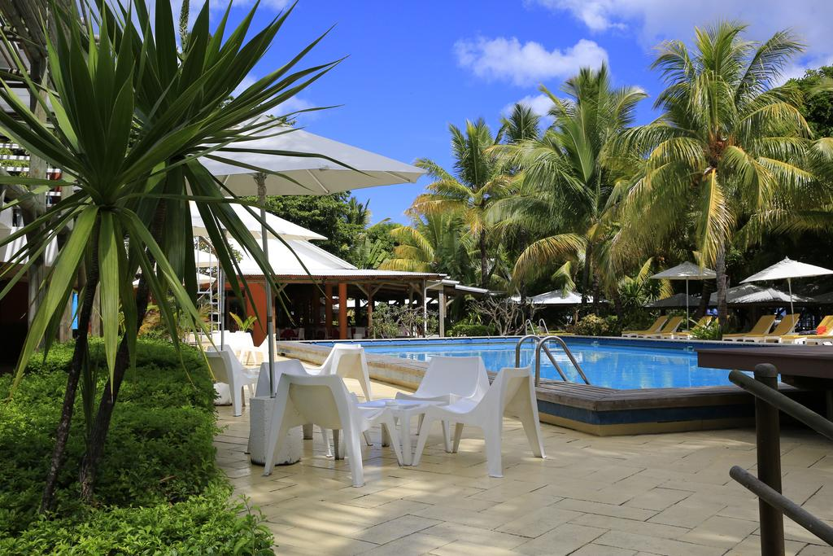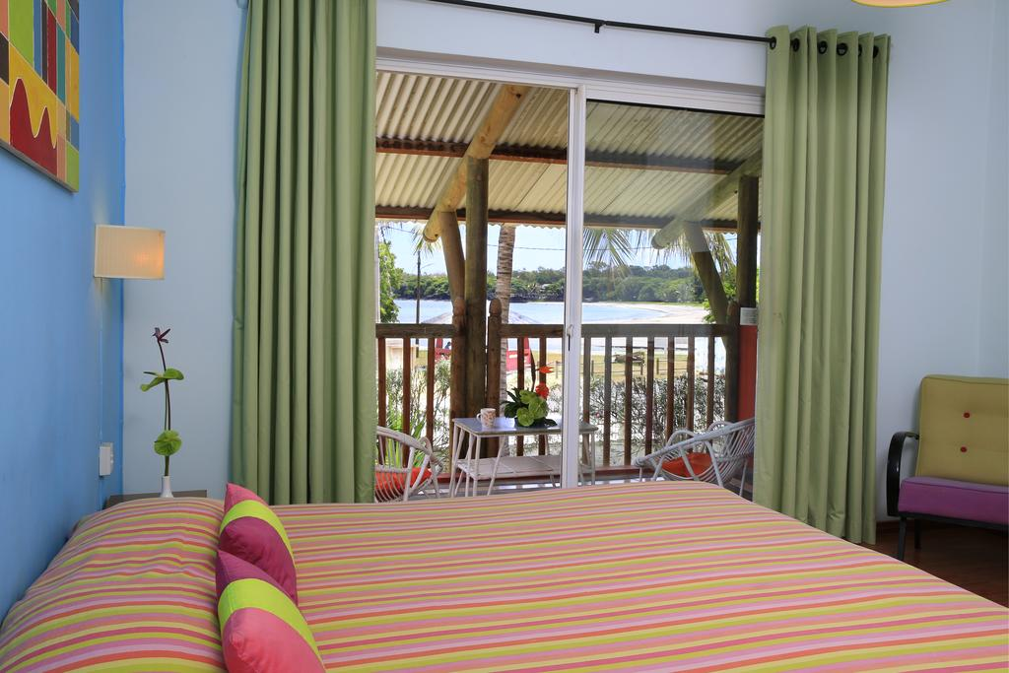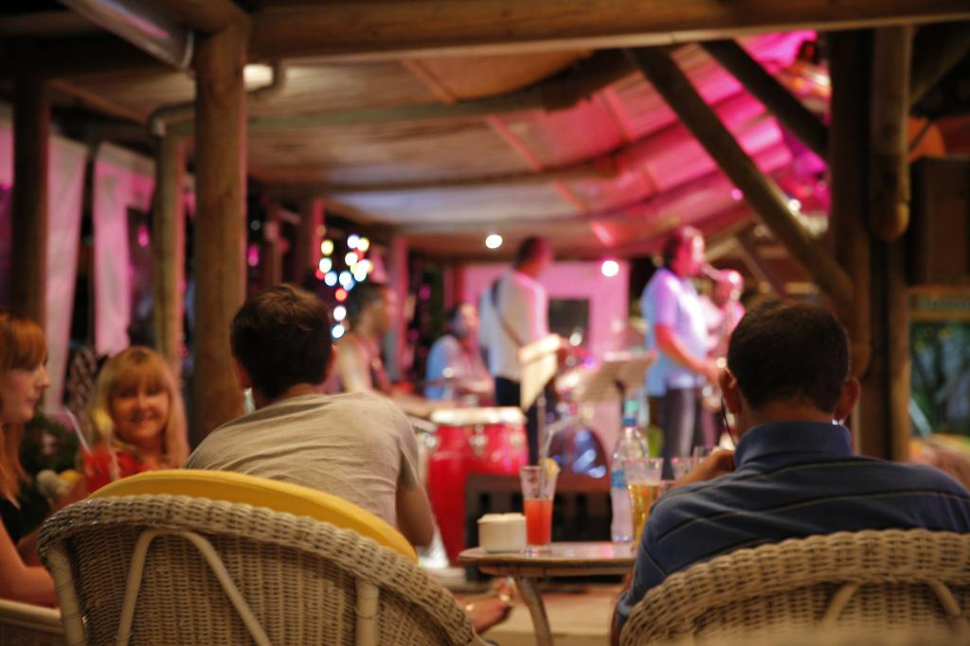

TAMARIN HOTEL 3* - MAURITIUS

TRANSPORT AVION - PLECARI DIN BUCURESTI

Localizare: Proprietatea se afla in localitatea Tamarin, la 2 minute pe jos fata de plaja. Aeroportul Sir Seewoosagur Ramgoolam se afla la 50 de minute de mers cu masina.

Facilitati hotel: piscina, centru wellness, Wi-Fi, restaurant si bufet, teren de tenis, club pentru copii, loc de joaca.

Facilitati camere: Camerele ofera balcon, TV prin satelit, aer conditionat, ceainic electric, minibar. Baia proprie include uscator de par, articole de toaleta gratuite, cada sau dus, canale prin cablu, TV cu ecran plat, etc.

Site oficial: http://hotel-tamarin.com/en

Orar de zbor pachete 7 nopti cazare, plecari Bucuresti
Dus:
Bucuresti Vineri (21:35) -> (00:05) Sambata Istanbul (02:20) -> (13:10) Port Louis Mauritius Sambata
Intors:
Port Louis Mauritius Sambata (21:05) -> (06:00) Duminica Istanbul (08:15) -> (08:35) Bucuresti Duminica

Orar de zbor pachete 9 nopti cazare, plecari Bucuresti
Dus:
Bucuresti Miercuri (21:35) -> (00:05) Joi Istanbul (02:20) -> (13:10) Port Louis Mauritius Joi
Intors:
Port Louis Mauritius Sambata (21:05) -> (06:00) Duminica Istanbul (08:15) -> (08:35) Bucuresti Duminica

