

Excursion | Adult | Child | Child Age | Transfer per person | Meals
Mamma Mia 🌊 | 45,00€ | 25,00€ | 5-12 | 5,00€ | -
Sea and Sun🌞 | 40,00€ | 25,00€ | 5-12 | 5,00€ | -
Island Hopping🏝️ | 55,00€ | 35,00€ | 5-12 | 5,00€ | -
Sailing Cruise*⛵ | 135,00€ | 100,00€ | 4-10 | 2,50€ | Included
4x4 Adventure🚙 | 89,00€ | - | - | - | -
Wine Tasting🍷 | 70,00€ | - | - | - | -
Taste Greece and make a dog’s day🐶 | 70,00€ | 50,00€ | 5-12 | Included | Included
Snorkeling Safari 🤿 | 90,00€ | 90,00€ | 8+ | 5,00€ | Included
Sacred Skiathos🙏 | 40,00€ | - | - | Included | -
Skiathos Town Walk🚶‍♂️ | 40,00€ | - | - | Included/One-way | -
Sunset Cruise🌅 | 35,00€ | 23,00€ | 5-12 | 5,00€ | One drink
Scuba Diving 🤿 | 85,00€*** /95,00€** | - | 10+ | - | -
Fishing Experience🐠 | 150,00€ | 150,00€ | - | 5,00€ | Included
Skiathos Garden Theatre 🎭 | 18,00€ | 12,00€ | 6-12 | - | -

*: For the Sailing Cruise there is only one-way transfer available.
**: For the specific excursion this price applies for beginner divers.

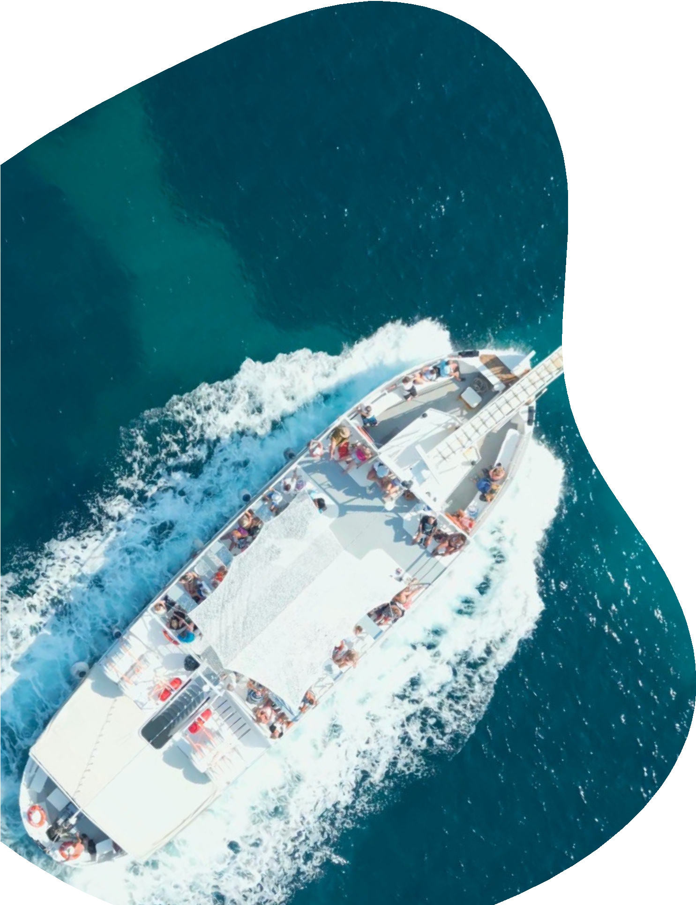
***: For the specific excursion this price applies for experienced divers.

