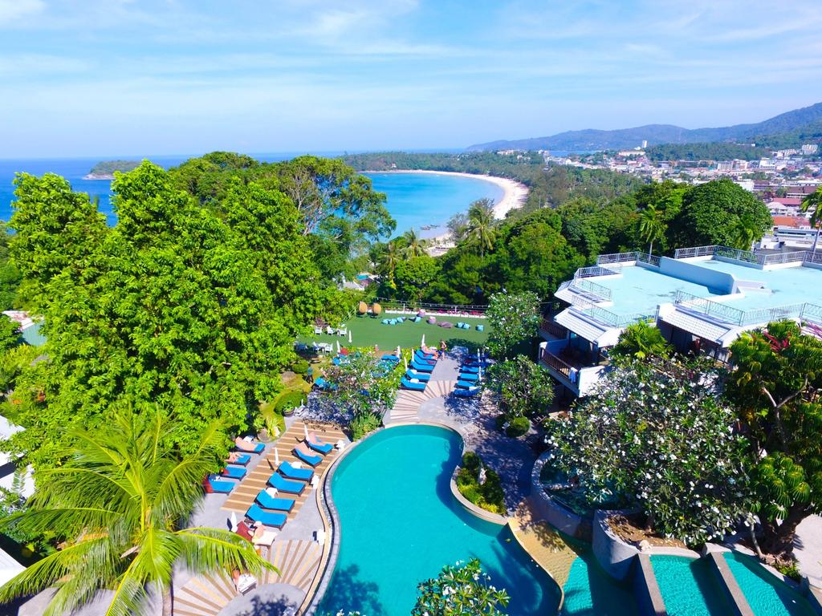
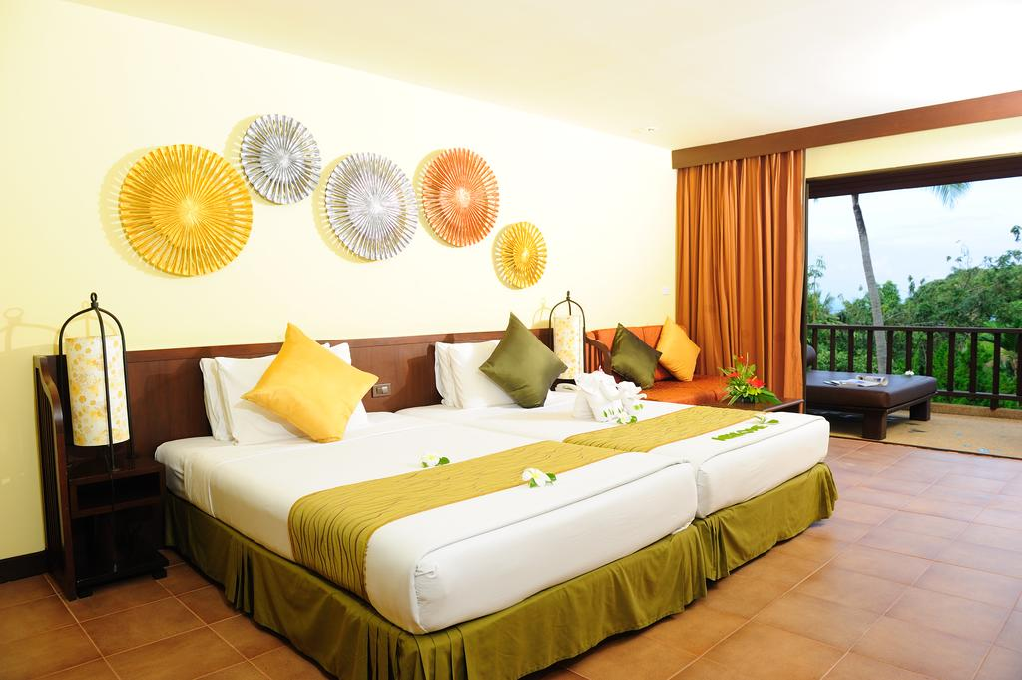
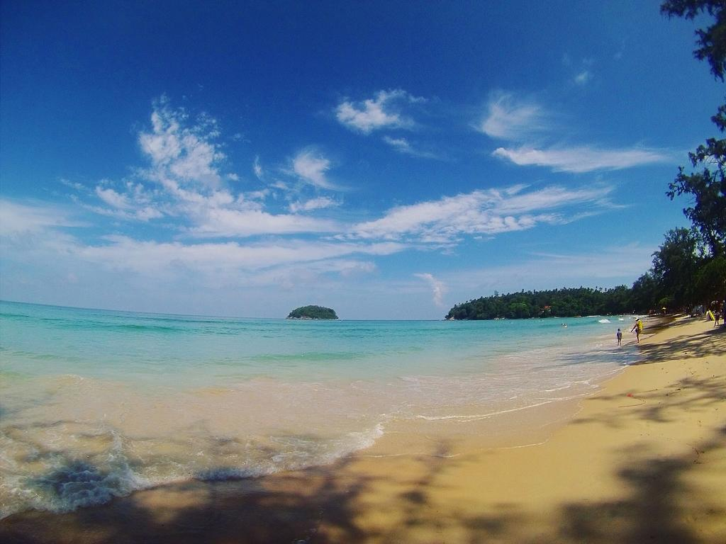

ANDAMAN CANNCIA RESORT & SPA 4* – KATA

TRANSPORT AVION - PLECARI DIN BUCURESTI

Localizare: Andaman Cannacia Resort & Spa se afla la 4 minute de plaja Kata, 20 de minute de plaja Patong si la 30 de minute de orasul Phuket. Aeroportul International Phuket este la 45 de minute de mers cu masina fata de hotel.

Facilitati hotel: Hotelul Andaman Cannacia dispune de: terasa, gradina, piscina in aer liber, centru spa, sauna, sala de fitness, Wi-fi gratuit, camera de bagaje, parcare, schimb valutar, receptie, sali de conferinte, rent a car.

Facilitati camere: Camerele spatioase si decorate in stil thailandez dispun de balcon sau terasa, minibar, dus, cada, uscator de par, frigider, zona de relaxare, baie, canale TV, prosoape.

Site oficial: http://www.phuket-cannacia.com/

Orar de zbor:

Pachete 9 nopti
Dus:
Bucuresti Sambata (09:55) -> (12:25) Istanbul (15:15) -> (04:30) Phuket Duminica
Cluj Napoca Sambata (09:45) -> (12:25) Istanbul (15:15) -> (04:30) Phuket Duminca
Intors:
Phuket Marti (05:50) -> (12:55) Istanbul (19:50) -> (20:05) Bucuresti Marti
Phuket Marti (05:50) -> (13:05) Istanbul (19:50) -> (20:35) Cluj Marti

Pachete 7 nopti
Dus:
Bucuresti Luni (09:55) -> (12:25) Istanbul (15:15) -> (04:30) Phuket Marti
Cluj Napoca Luni (09:45) -> (12:25) Istanbul (15:15) -> (04:30) Phuket Marti
Intors:
Phuket Marti (05:50) -> (12:55) Istanbul (19:50) -> (20:05) Bucuresti Marti
Phuket Marti (05:50) -> (13:05) Istanbul (19:50) -> (20:35) Cluj Marti

