*MAMMA MIA the movie….HIGHLIGHTS….*

Join now every WED & SUN our mini bus day out to the

Most popular movie locations on Skopelos.

Our day sets off at 9:00hrs driving up to the north of the island to visit the Ag.Ioannis Chapel …the MAMMA MIA wedding church. There you get some free time to walk up and get into the MAMMA MIA movie feeling or simply enjoy the stunning views and the absolute sea breeze from the top of the rock.

Don’t you think its about time for our swim stop??

Well…only one movie location could ever be the best place to enjoy the crystal clear waters and the natural beach surroundings..and that’s our second stop for the day at the Kastani Beach…Major filming took place down for more than 10 days. The beach was chosen due to its location and being so non developed it proved to be the perfect filming setting…

Our swim stop will be for about one hour …on your way back to Skopelos please make sure you are dressed with dry clothes so we don’t wet badly any of the bus seats…

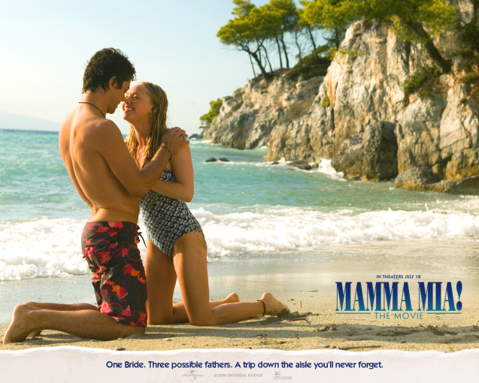Book now with the Dolphin of Skopelos

Or with your Holiday rep…

Price per adult 30 euros