#### SUNSET KAYAKING

**Enjoy the beauties of our coastline and the amazing colors of the sunset on our evening kayaking trip.**

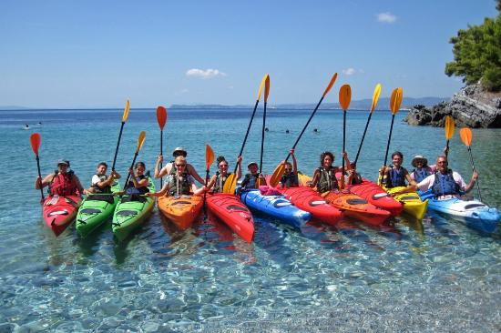There are both single and double kayaks and Neil, who is the guide, will offer you all necessary equipment and information. Expect to cover a distance of about 3 km at a very relaxed pace.

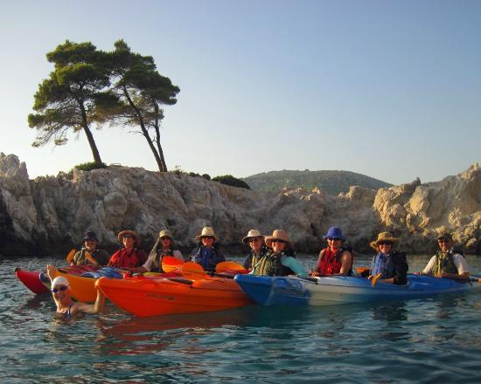One of the highlights of this evening will be the Amarandos Cape with its 3 trees on the top. This is one of the most beautiful nature spots on the island and we will go close to take photos.

Kayaking is good exercise and Neil has made the necessary preparations for a light snack with fruits and water which you will enjoy followed by a swim in a small natural cove or beach along the way.

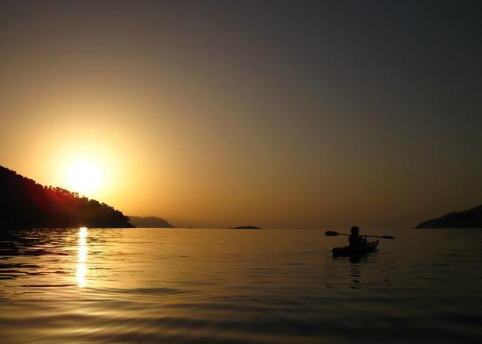We end this trip in the amazing sunset going back to the beautiful little fishing port of Agnondas and you can choose to take our transfer bus back to Skopelos or to stay for dinner in one of the lovely sea side tavernas and then make your own way back later in the evening.

There are snorkels and underwater cameras available on board to explore the crystal clear sea and capture your experiences.

Any photos taken with our underwater camera will be e-mailed to you.

***A beautiful and fun evening expedition !! C:\Users\Mette\AppData\Local\Microsoft\Windows\Temporary Internet Files\Content.IE5\2RNW2EHC\MC900326492[1].wmf***

ADULT PRICE 29 EUROS / CHILDREN PRICE 29 EUROS

