#### AEGEAN PARADISE CRUISE

**Our cruise on board the traditional wooden boat “Gorgona” will take you to the deserted island of Kyra Panagia of Greece’s biggest National Marine Park.**

If you prefer a small exclusive cruise rather than a large crowded tour boat this should be your choice. Our cruise is created and operated exclusively by Dolphin of Skopelos. The owner & captain of the boat is called Pakis, and he has been doing these trips for 14 years. He is an excellent guide and will offer you lots of useful and interesting information throughout the day.

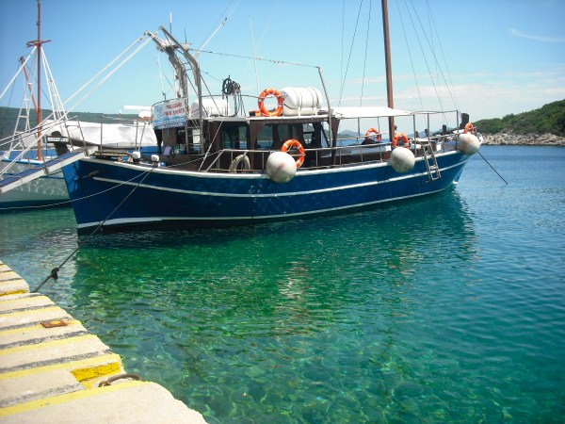

The boat leaves from Skopelos port at 09.00 and the first stop will be on the sister island of Alonissos. Here you will have time for a drink and a wander around the little port before we continue far up into the Marine Park to the island of Kyra Panagia. On Kyra Panagia is a monastery dating back to year 993. Walk together with Pakis up the steep donkey track to the monastery and he will give you a guided tour of the old sacred setting.

Back on the boat you will enjoy a light lunch and a swim, before Pakis takes you to one of the best beaches in the area for swimming, snorkeling and sunbathing. The crystal clear waters and the sceneries of the marine park are breathtaking, and the endangered monk-seals and giant turtles could be spotted here. Dolphins are usually playful and plentiful and they are likely to join you playing in front of and raising the boat. Our cruise boat will return along the coast of Alonissos and reach Skopelos Port around 19.00.

***FANTASTIC full day out on a lovely boat in great company !! C:\Users\Mette\AppData\Local\Microsoft\Windows\Temporary Internet Files\Content.IE5\2RNW2EHC\MC900326492[1].wmf***

EVERY SUNDAY & WED – lunch included + refreshments with your lunch

ADULT PRICE 49 EUROS / CHILDREN PRICE 33 EUROS

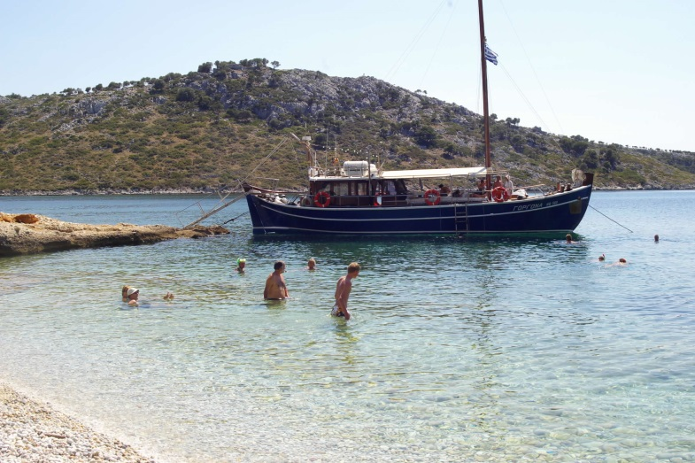 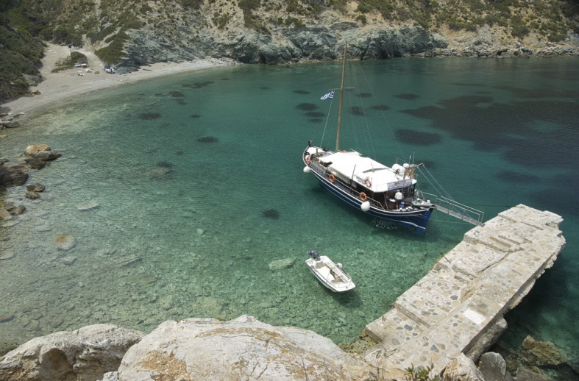

The traditional wooden boat “Gorgona” The jetty at Kyra Pangia

The steps for the monastery

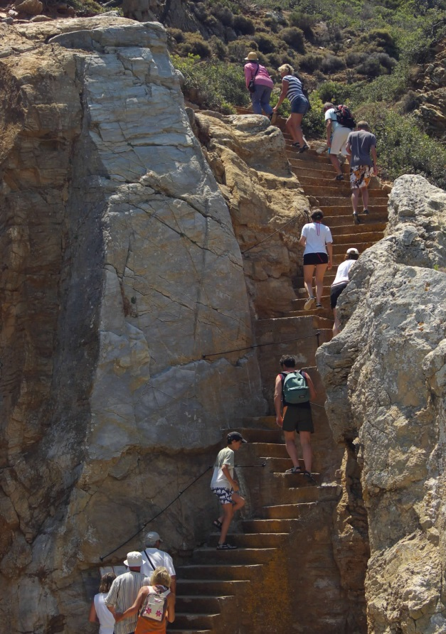

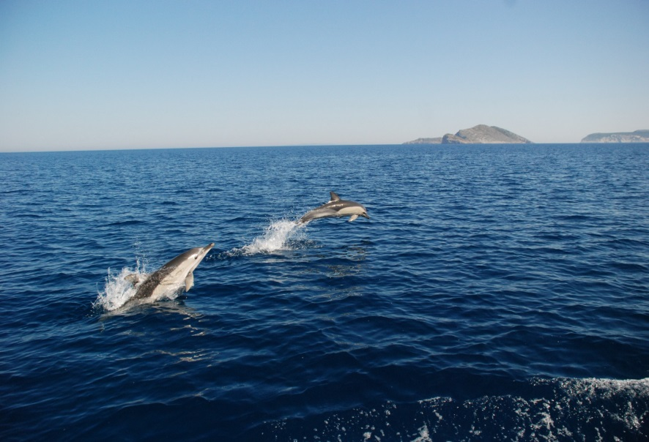

Playful dolphins….

The court yard of the old monastery

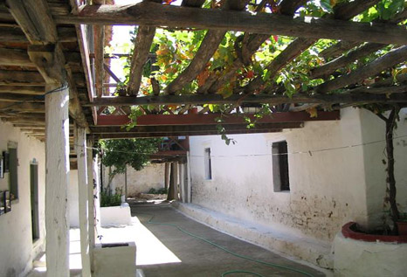

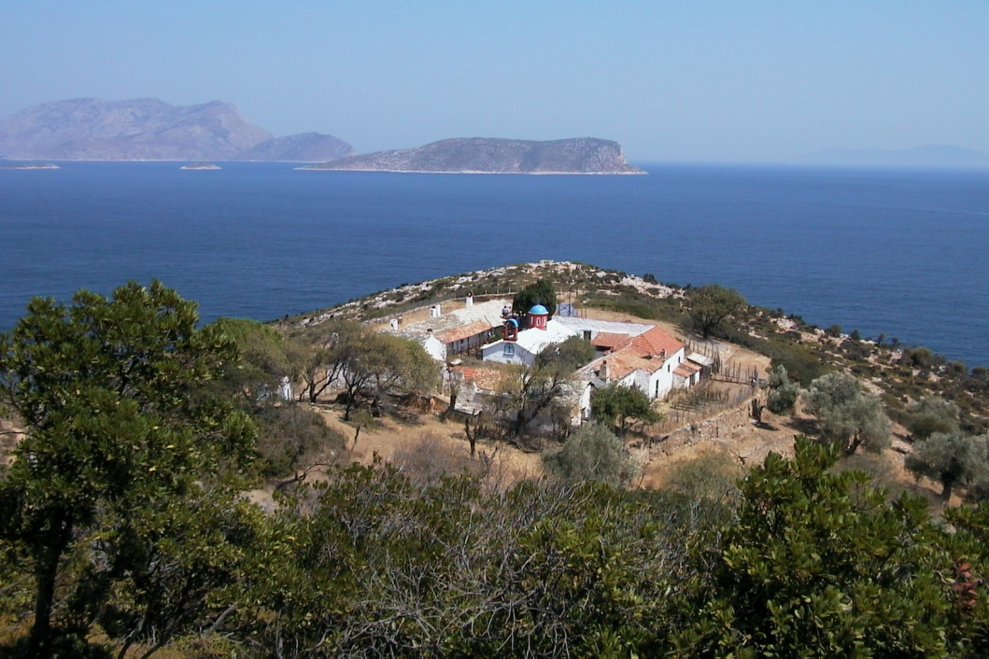 The monastery at Kyra Panagia

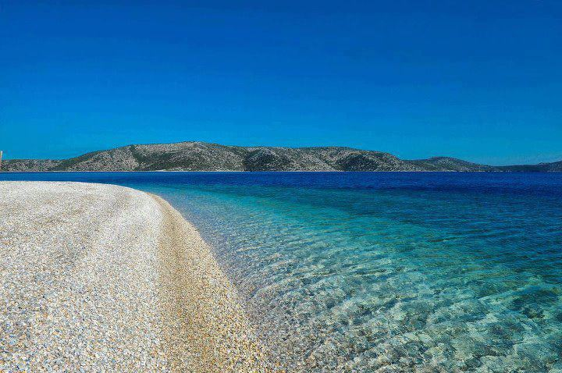 A paradise beach in the

Marine Park

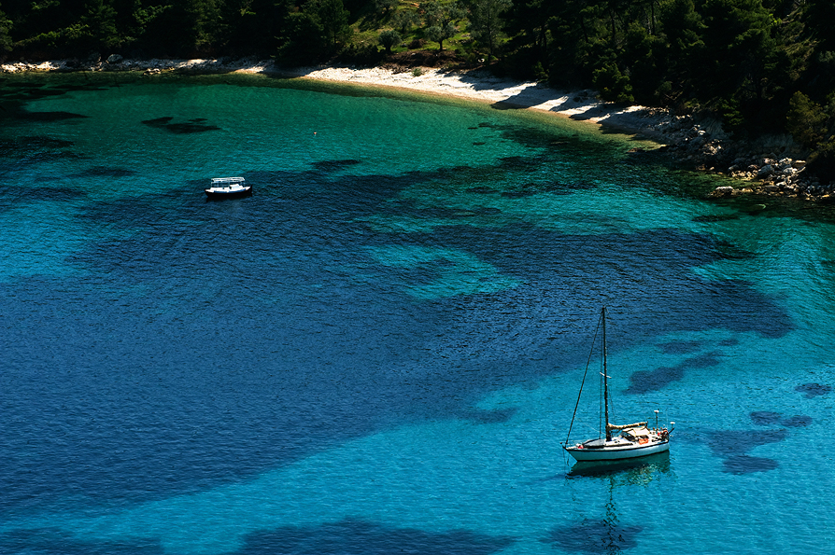

Beautiful bay in the

Marine park

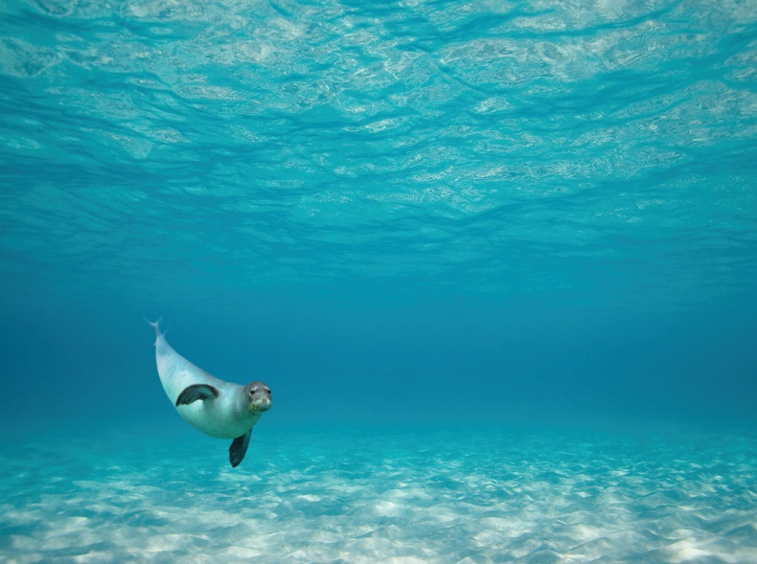 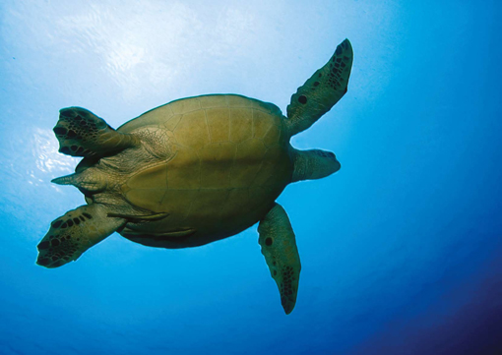

The rare monk seal “Monachus Monachus” Giant turtle “Kareta Kareta”

Map of the largest National Marine Park of Greece

